|  |  |
| --- | --- |
| Date | 19 SEPTEMBER 2022 |
| TeamID | PNT2022TMID49188 |
| IBM-Project-ID | IBM-Project-28736-1660115651 |
| ProjectName | SignswithSmartConnectivityforBetterroadSafety |

Does this system will avoid accidents ?

Does this system helpful in real roads ?

Is this project really need for the road ?

Whether the system is used to control the traffic ?

How does this board calculate the speed of the vechicle ?

How does this system analyse the weather ?

Is it possible to implement the project ?

# People may try to violate the speed limit shown in the board.

They can change the modes or speeds if there is any network error using the button.

Do public will help and support to the system ?

Is this project can withstand in different climate and weather conditions ?

Does the board show correct speed limitations ?

Signs with Smart Connectivity For Better Road Safety

This problem might reduce the road accidents.

Boards that show warnings and services

Diversion signs in the board.

Drivers can see changing speed limits in the sign board.

Low traffic on the road.

Replaced sign boards instead of static boards

Riders will race among them by violating the speed limits.

BASED ON THE WEATHER CHANGES THE SPEED MAY INCREASE OR DECREASE.

some times the user may experience network problem to acess about road conditions

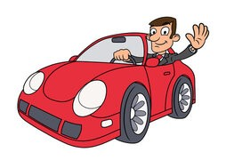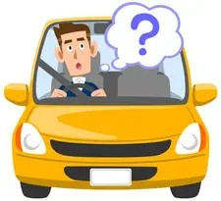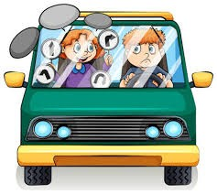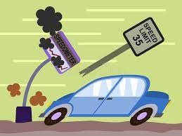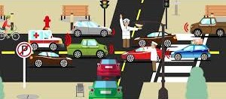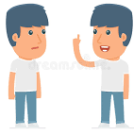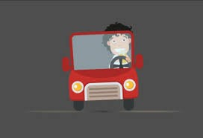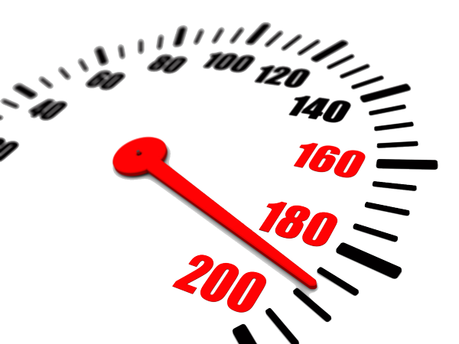

This project may take more time for implementation and it is a complicated process.

Does this project will enhance the roads ?

Incresae in the less-adiquate roads to avoid traffic signs

Failure of signal due to electric power failure or any other cause confusion to road users

Drivers will feel frustrated when there will be incompatible speed limit on the sign board.

Excessive delay to vechicle may caused in off peak hour.

The vehicles going through the traffic areas are diverted to other road.

Oppurtunity to save lives through static sign boards

Device monitored by every moment and accident should identified easily

Not only speed limits but also the directions will be shown.